**General Objective:**

Upon completion of this lab, the student will be able to:

1. Calculate voltages, currents, gains, slew rate, common mode rejection ratio for differential & operational amplifier circuits.
2. Construct, measure, and demonstrate the proper use of the test equipment.

**References:**

* Theory notes
* First Year Text & Lab books
* [LM741 Datasheet with offset null](https://github.com/leistimo/RCET_ThirdSemester/blob/master/RCET2253/Lab%207/LM741DatasheetOffSetNull.pdf)
* [MCP6002 Datasheet](https://github.com/leistimo/RCET_ThirdSemester/blob/master/RCET2253/Lab%207/MCP6002DataSheet.pdf)
* [TL071 Datasheet](https://drive.google.com/file/d/1gL9TmLWqYtbK7Xb5qaRlgTzlDshF5MG8/view?usp=sharing)

**Check-Off Sheet:**

* [Check-Off Sheet](https://github.com/leistimo/RCET_ThirdSemester/blob/master/RCET2253/Lab%207/TL071DataSheet.pdf)

**Specific Objectives:**

Notes.

* 1. Theory Notes
  2. First year Text & Lab books

1. Operational Amplifier Review
   1. Write in your lab book the two rules for an Op-Amp.
   2. Describe voltage gain open loop vs. closed loop.
   3. Show Operational Amplifier common configurations.
   4. Show steps for calculating voltage gain.
   5. List the slew rate and CMRR specification found in the data sheet for the LM741, MCP6002, and TL071.
   6. Show in your lab book how to test and measure slew rate.
   7. Demonstrate a slew rate measurement.
   8. **Instructor Check 1f.**

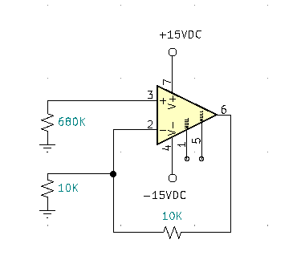

1. Offset Null
   1. Assemble the above circuit.
   2. Measure the output DC offset voltage and record it in a table.
   3. Calculate the balancing resistor that the circuit should have and replace RB with the proper resistance. Re-measure the output DC offset voltage and record it in the table.
   4. Properly connect the offset null pins for zeroing DC offset of the operational amplifier. Adjust for a zero-offset voltage. Document in your lab book the zeroing procedure and what you learned.
   5. **Instructor Check**
2. Calculate and construct an Op-Amp Differential Amplifier with the same gains from your Transistor Differential Amplifier Lab. Compare the common mode and differential mode gains, and the CMRR of both circuits. **Instructor Check**
3. 3-Stage Operational Amplifier
   1. Design a Single-Stage Operational Amplifier with the following specifications:
      * RL is 10Ω
      * Voltage Gain Total is -425.
      * Prior to connecting to the circuit, the generator is set to 60mVpp (unloaded).
   2. Show all calculations for your design including High Critical Frequency.
   3. Repeat steps a & b with a second stage (one inverting & one non-inverting)
   4. Repeat steps a & b with a three stage (one inverting, one non-inverting, your choice)
   5. **Instructor Check**
   6. Build, measure and annotate data in lab book.
   7. **Instructor Check**
4. ~~Voltage Bounding~~
   1. ~~Design a voltage bounding circuit that will prevent output signal from varying above a specified (instructor assigned) level. The load resistance is 2.2K.~~
   2. ~~Build and test circuit.~~
   3. **~~Instructor Check~~**
5. Comparators
   1. Design a circuit using Op-Amp Comparators to light one LED requiring 10mA, when a 5V supply goes above 6.0V or below 3.9V.
   2. **Instructor Check**
   3. Use Voltage Bounding to adapt the circuit to provide TTL high and low outputs.
   4. **Instructor Check**
6. Complete Conclusion and submit completed Check-Off sheet and Lab writeup in Moodle.